|  |  |  |  |  |  |
| --- | --- | --- | --- | --- | --- |
| Date | 28-Nov-22 | | | Tester Name | Richard Belanger |
| Environment | Penfax - Test | | | Login used | Test 2 |
| Operating System | Windows | Version: | Update: | | |
| Software Used | Edge | Version: | Update: | | |
| Not Applicable | Version: | Update: | | |
| Release version | 22.4.1 | | | | |
| Title | M7.03 General 12 Month Member with other service types | | | | |
| Test Type | Regression | | | | |
| Test Scenario | 12 Month Member will be Terminated and payment produced | | | | |
|  |  | | | | |
| Expected Results | Member will be Terminated and payment produced with correct taxes withheld | | | | |
| Pass/Fail | Pass | | | JIRA# | N/A |

Describe your steps with screenshots:

12 Month member has Purchase of service

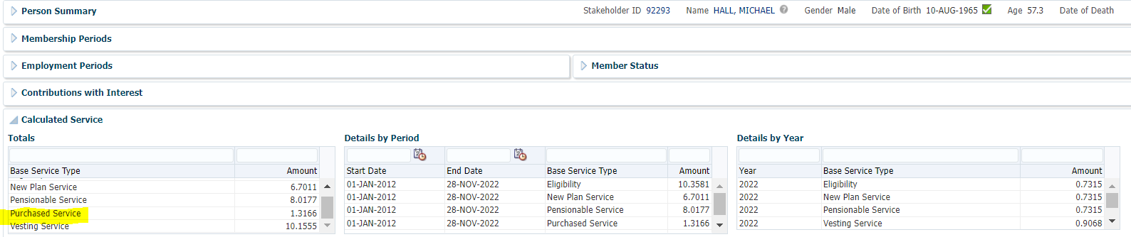

Terminate Member

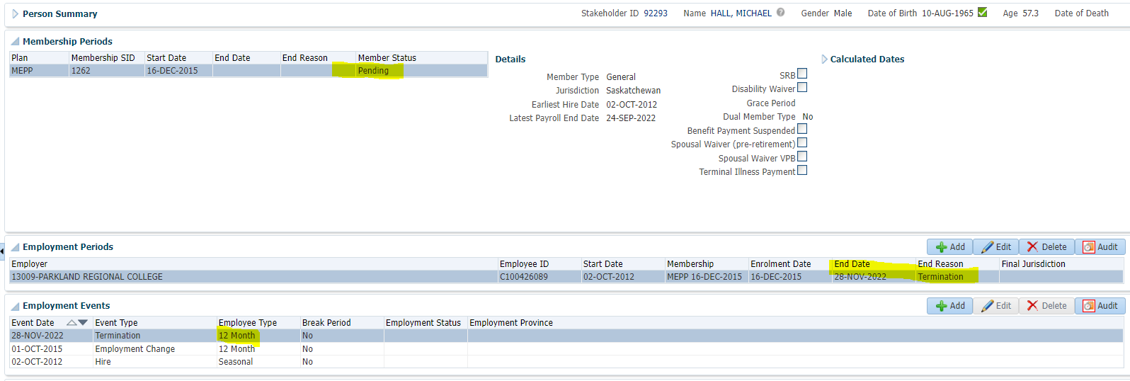

Benefit Calculation>Calculate

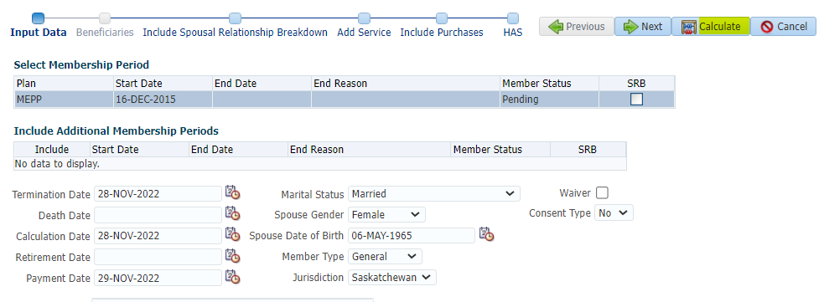

Processed

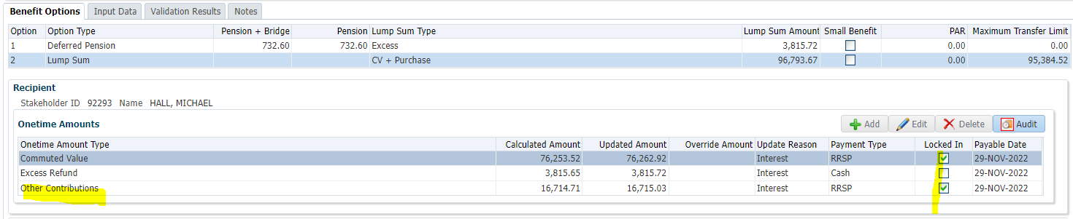

Benefit Selection>Next

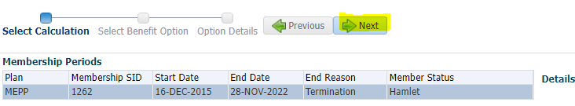

Choose Lump Sum add Payment date>Next

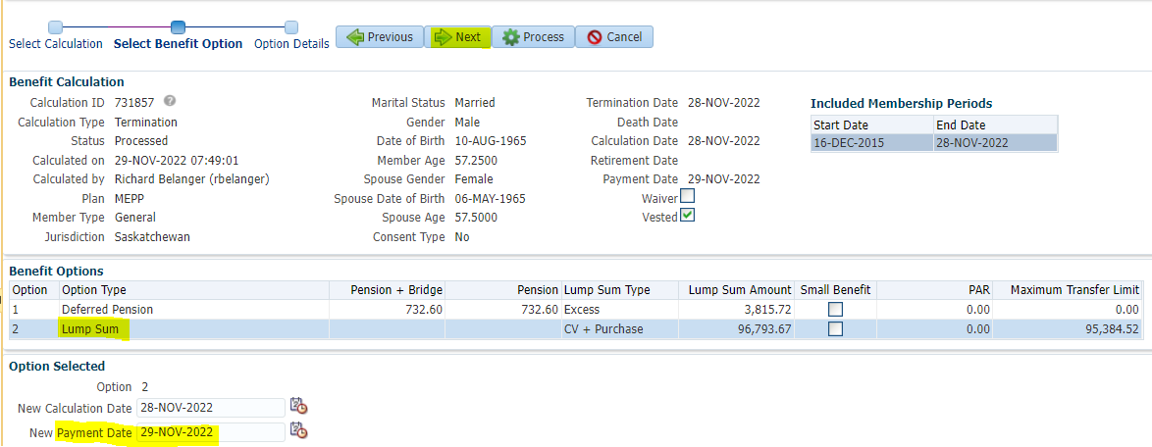

Add Payment instructions>Process

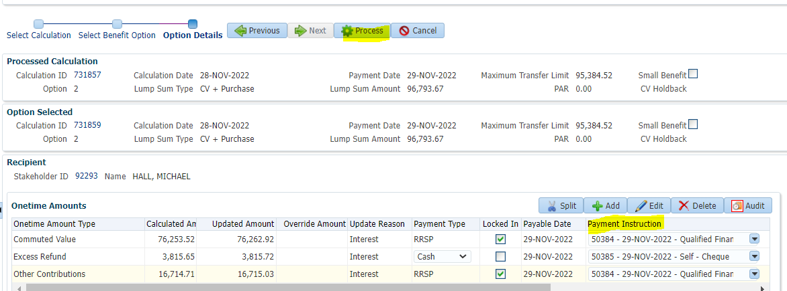

Benefit Recipient

Approve and Authorize payment

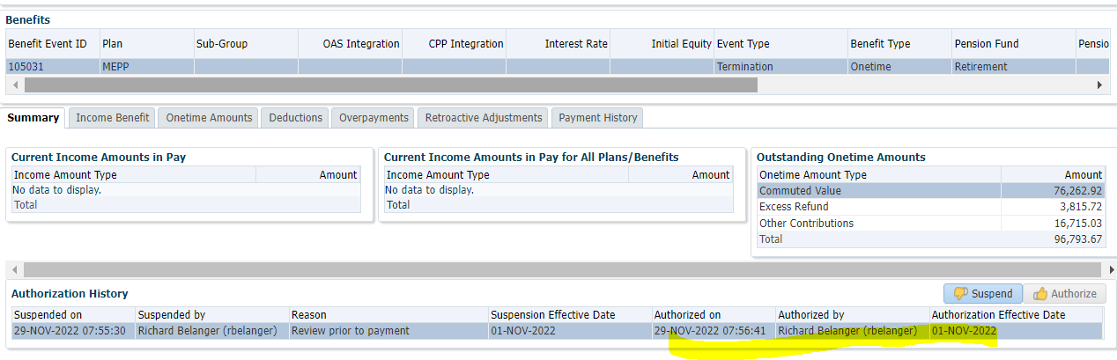

Payment production created payment

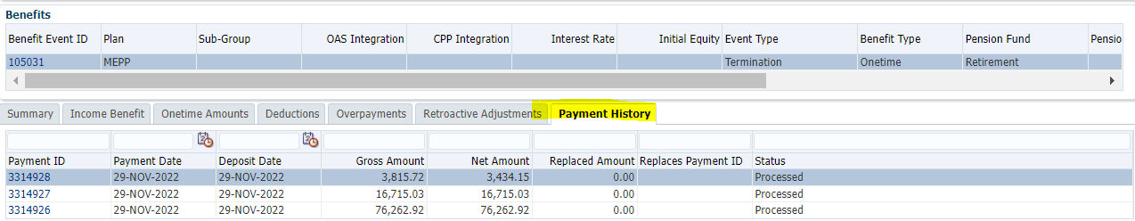

Tax Rates

0.00-4,999.99 = 10%

5,000.00- 14,999.99 = 20%

15,000.00+ = 30%

3,815.72 x 10% = 381.58; 3,815.72 – 381.58 = **$3,434.15**

RRSP amounts are not taxed payment is $76,262.92 + $16,715.03